Project Overview

“What Yuh Know Bout Guyana?” is terminal based game written in C. It consists of multiple-choice questions themed around Guyana such as; sports, geography, history, nature and culture. Players enter their name, pick a category and difficulty level before each round, the higher the difficult level the less lives you are granted. Players are then given a multiple-choice question with four possible answers based on their selected category, for every correct answer given points are awarded and every incorrect answer costs the player a life, the round ends when either all questions have been answered or all lives were lost. The scores of every player are tracked across the sessions and updated to a top 10 leaderboard.

Features in the game:
- Five different categories of questions: Geography, History, Sports, Culture and Nature, all of which are Guyana based.
- Category Selection: players can either choose on specific category or a random mix from all 5 before every round.
- Real-time feedback on answers: players will be notified players after every question whether they were right or wrong.
- Score history: each player’s last 5 scores are stored and can be viewed from the main menu.
- Leaderboard: a 10 leaderboard is kept.
- Difficulty levels: There are 3 difficulty levels, each gives a different score and starting lives.
- Bonus points: every 5th question is worth double points

The application is spilt across 3 source files (.c) and 2 header files (.h). A .txt file is then used to save scores across the sessions.

User Documentation
Requirements and how to start and play the game.

System Requirement
- Windows, macOS or Linux operating system
- GCC compiler
- A terminal / command prompt
- All files should be in the same folder

Compiling and Running
Open a terminal, navigate to the folder containing all the files and run the following commands;
Windows
- gcc -Wall -Wextra -o quiz.exe main.c questions.c scores.c
- & .\quiz.exe
Linux/ macOS
- Gcc -Wall -Wextra -o quiz main.c questions.c scores.c
- ./quiz

Main Menu
When the game starts you will be asked to enter your name which is used to track the players personal score history. After the name is entered the main menu will appear listing where you will be asked to type the number of your choice and press enter.

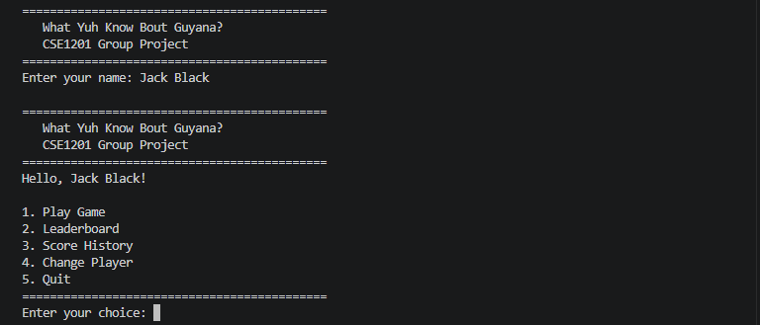

Playing a Game

Choosing a Category
A list of categories will be shown:

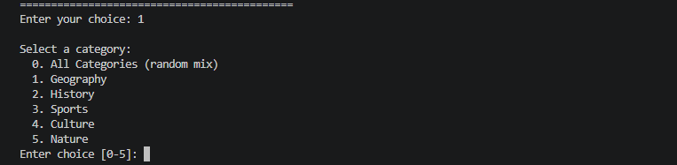

Enter 0 for random category or individually selecting a specific topic from 1-5.

Choosing a Difficulty
There are three difficulty levels;

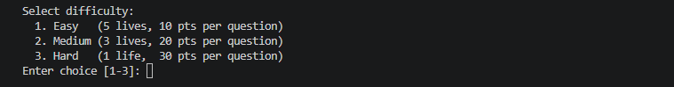

Answering the questions
Each question has four options labelled A, B, C and D. You type the answer of your choice, input can be lowercase or uppercase as we have a toupper function to handle the input. When enter is pressed:
- If correct: you are awarded a score based on the difficulty level chosen.
- If wrong: you will lose one life and the correct answer is chosen.
- Every 5th question is a classed as a bonus question that is worth double points.
- Bonus points every 5th question.
- One round ends when all the questions are finished or when you lose all your lives.

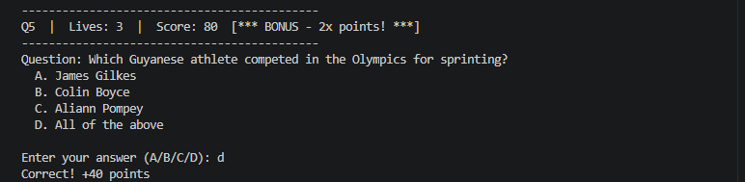

End of the Round
When the round ends your total score, questions asked and lives remaining will be displayed. Your score is automatically saved to your personal history checked against the leaderboard. Game then loops back to the menu.

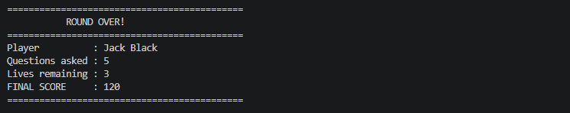

The Leaderboard
Option 2 in the main menu allows you to view the top 10 best scores across all the players. The leaderboard is saved between every session so scores don’t get lost when the program closes.

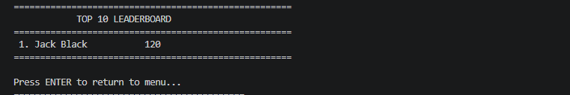

Your Score History
Option 3 from the main menu allows you to see your five more recent scores.

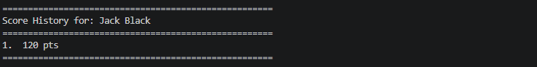

Changing the Player
Option 4 allows you to switch to a different player name.

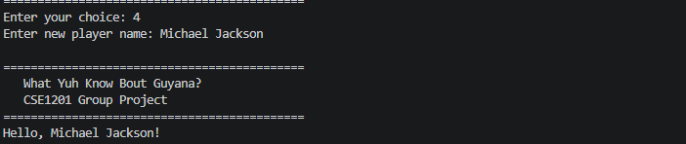

Quitting the Game
Option 5 saves the scores automatically before exiting the program.

Technical Documentation

Structure of Project

The project is spilt across three modules with 2 header files and a plain text file. Each file is responsible for a specific aspect of the game. These files are:

File | Function
main.c | The entry point, handles the main menu loop, player name and loads the other modules.
questions.c | Stores, load, print and ask all the questions.
questions.h | Defines the question and category structure and declares the functions for question.c.
scores.c | Handles score tracking and the leaderboard.
scores.h | Defines the PlayerRecord and LeaderEntry structures and score functions.
scores.txt | Saves scores so they are not lost when the program closes and can be accessed when restarted.

Data Structure

questions.h – Structures and Delcarations

Include Guard

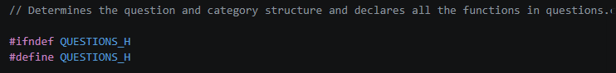

This function ensures that the compiler would see the struct definitions once and not throw an error since it questions.h is included in both main.c and questions.c.

Question Structure

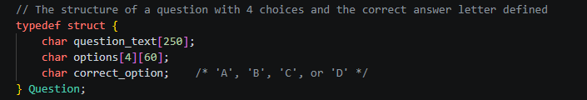

Code | Type | Function
question_text | char[250] | The question has a character limit of 250.
options[4][60] | char[4][60] | A 2d array that has 4 strings for the answer choices and each with a character limit of 60.
correct_option | char | The letter of the correct answer.

A char is used to store the correct answer because it makes checking the player’s answer simpler, input is uppercased and compared directly against it.

Category Structure

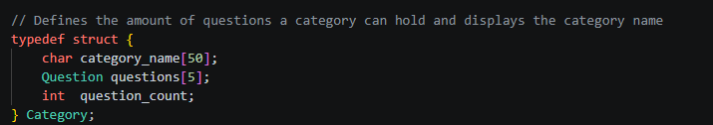

Code | Type | Function
category_name | char[50] | The category name has a character limit of 50.
questions[5] | Question[5] | A fixed array of up to 5 questions for a category.
question_count | int | Show how much questions have been loaded and prevents reading uninitialized arrays.

We used a fixed array of 5 because each category will only have 5 questions. If we used dynamic memory allocation it would make it more complex. The question_count field tells the program how many slots in the question array are filled, without this, the code will not know where the real data ends and where uninitialized memory begins.

Declaring Functions

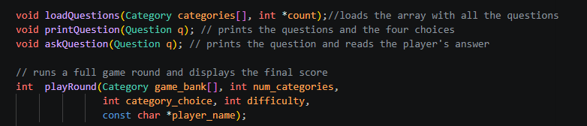

Declaring functions in the header means any file that includes questions.h can call these functions without having to know how they work.

main.c – Starting the Game

main.c contains no game logic or scoring logic in this file, its just is to start the program, collect player names and keep the menu running. It carries out this by calling functions from questions.c and scores.c.

Include and Headers

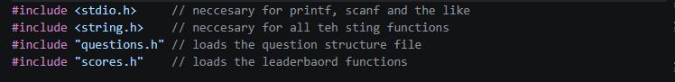

flushInput()

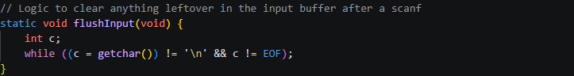

After scanf() reads a number it leaves a newline character in the input buffer, if this is not cleared then the input read would pick it up and will skip waiting for the player. The flushInput() line clears everything in the buffer. It is set to static because it is only needed in the main.c file.

Startup Sequence

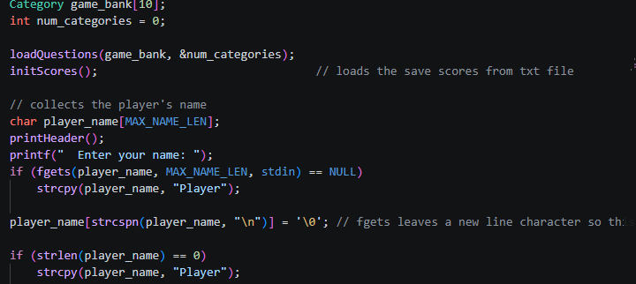

We use fgets() instead of scanf() for the name because it read the entire line of input which includes the spaces. Whereas, scanf() would stop at the space so if you were type your full name it would only read the first.

chooseCategory()

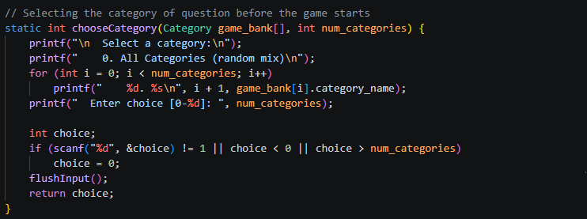

These check if scanf() returns 1. If a letter is entered instead of a number, scanf() will fail and return 0. Without these choice will get a incorrect value and cause unexpected behavior.

ChooseDifficulty()

In this section same check is done for if something weird is entered, game defaults to easy.

Main Menu Loop

Choice | What is called
1 | Calls chooseCategory() then chooseDifficulty() and then playRound() with the results.
2 | Calls showLeaderboard() from scores.c to print the top 10 all time scores
3 | Calls showPlayerHistory() from scores.c to show the current player's last 5 scores.
4 | Accepts input with fgets() for a new name and replaces the current player_name.
5 | Sets running = 0 so the while loop will end and the program will close.

questions.c – All Question Data and Game Logic

This file is responsible for storing all 25 questions in loadQuestions() and running the game round in playRound() along with other helper functions.

loadQuestions()

This function initializes when the game starts and loads all of the question into the category array. Each question is then added one by one by writing its text, options and correct answer into the next open slot and then increasing the question count for the category.

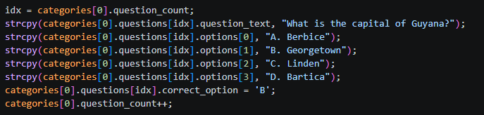

We use strcpy() to fill the text fields because C does not allow you to assign a string directly to a char array after it is declared. When all the five categories load, the functions sets the toyal category count to so the main.c file can know how many there is.

printQuestions()

Prints a question along with its four options on the screen. It is used by both askQuestion() and playRound() so the display code only has to be written once.

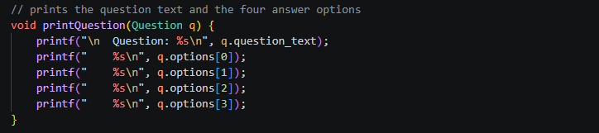

askQuestion()

This block of code accepts the answer input using scanf(), we use toupper(answer) so both lowercase and uppercase letters are accepted. if (answer == q.correct_option) checks the players answer against the stored data and prints whether it is correct or not.

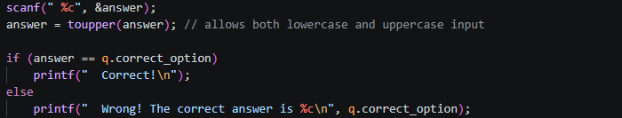

shuffle() – Fisher-Yates Algorithm

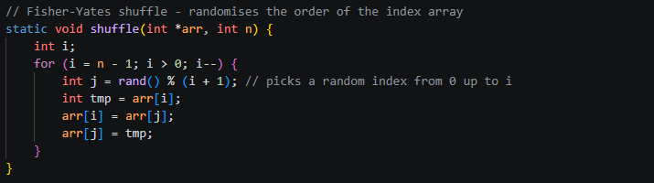

This function is used to ensure the questions are randomized every round. A list of numbers representing the question positions is used and randomly swaps pairs until the entire list is in a new order. The Fisher-Yates shuffle guarantees that every possible order of the question is likely. Shuffle uses a separate list of position numbers instead of moving the actual questions.

livesForDiffculty()

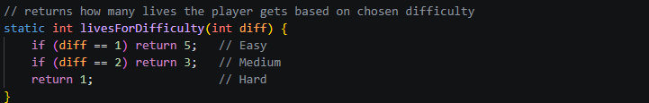

We have this mapping in its own function so the difficulty values never change, this one function allow can be updated.

playRound()

The random number generator

We use time(NULL) to return the current time as a number, srand() then uses that number as a starting point for rand. The time will always be different this way so shuffle will output a different order everytime.
The question pool
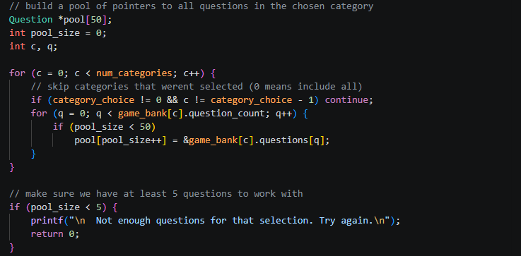

Pointers (memory address) are stored in the pool to the questions rather copying the question data. This avoids large chunks of data in memory.

Shuffling the Order

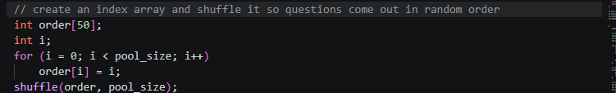

Questions are accesses as pool[order[asked]] rather than pool[asked], this means the question are outputted in the shuffled sequence without the pool array itself changing.

Question Loop

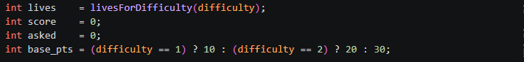

This block of code sets the starting lives and awards points based on the difficulty.

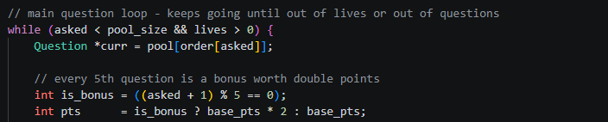

This block ensures that the game keeps running until lives reach zero, gets the next question using shuffle and handles the 5th question bonus points.

Reads the player’s input whether it is uppercase or lower case.

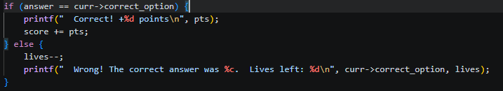

Checks for correct answer and adds points, if incorrect it removes a life.

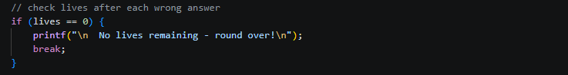

Ends the loop is all lives are finished.

End of Round

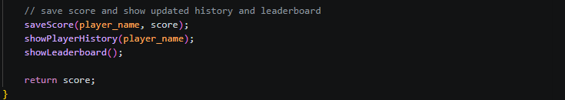

This block writes the player’s name and score to the scores.txt file, prints the player’s last 5 scores, the leaderboard and returns everything to main.c.

scores.h – ScoreEntry Structure

This file defines the ScoreEntry Structure and declares 4 functions that scores.c use.

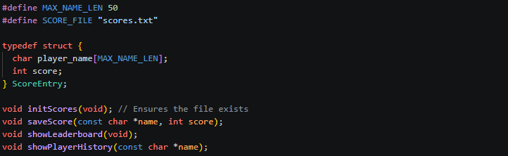

The codes in this file holds the players name, score value and name the ScoreEntry structure. The files are stored in scores.txt, when it is read, player_name gets the name and gets the number.

scores.c – Saving and Displaying the Scores

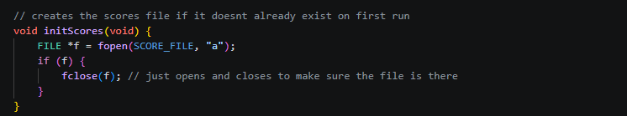

Opening a file in append mode (“a”) creates one if it does not exist without deleting anything. This function ensures that the file is there before the rest of the program tries to read from it.

saveScore()

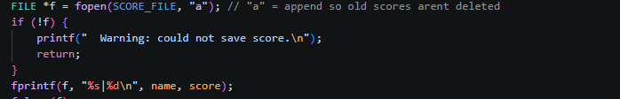

We use append mode (“a”) instead of (“w) so the file would not be wiped clean everytime a new score was saved, this ensures that previous scores are not lost.

sortScores() – Bubble Sort

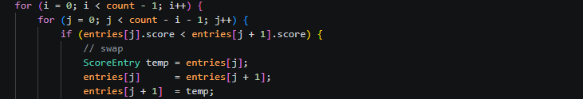

All scores are sorted from highest to lowest using bubble sort algorithm before showing the leaderboard. This algorithm constantly compares neigbouring entries and switches them if they are in the wrong order. The code works by passing the outer loop through the list, comparing pairs using the inner loop and if the left score is lower than the right then saves the left entry and move the higher score left and put the entry saved to the right.

showLeaderboard()

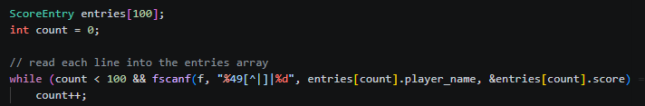

showLeaderboard() and showPlayerHistory() check if (!f) return after fopen(). If scores.txt cannot be opened or does not exist the function exits safely without crashing. We chose 100 as the array size because it is large enough to hold the scores while keeping the array stack-allocated and simple. The while loop condition count <100 is safety cap, if the file was to get larger, the program would stop reading at 100 instead of writing beyond the boundary.

showPlayerHistory()

We %49[^\n] used instead of %49 because %S stops reading at a space, whereas, %49[^\n] reads everything up to the newline character so this was the full name is captured. This first line of code reads each line from the txt file, second line checks which line belongs to the player and if so add to their history.

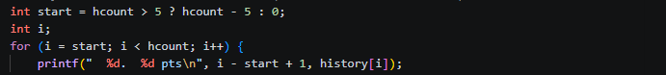

The first line checks if more than 5 scores exists and if so, only show the last 5. The second line loops from the start to the end and the last line prints the scores.

Design Decisions

